RV UNIVERSITY, BENGALURU

SCHOOL OF COMPUTER SCIENCE AND ENGINEERING


A Project Report On
Wildlife Tracking And Monitoring System
B.Tech(Honors) In
School of Computer Science and Engineering Submitted By

Veena Shanmukh: 1RUA24CSE0527 Venessa Chrisy S : 1RUA24CSE0528 Vismaya Hiremath : 1RUA24CSE0540 Yashwitha TS : 1RUA24CSE0551

Course Name: Internet of Things [CS2404] Under the Guidance of
Dr. Sheela S Assistant Professor School of CSE
RV University, Bengaluru- 560059 2025-2026

RV UNIVERSITY, BENGALURU-59

SCHOOL OF COMPUTER SCIENCE AND ENGINEERING



CERTIFICATE

Certified that the project work titled Wildlife Tracking And Monitoring System is carried out by Veena Shanmukh (1RUA24CSE0527), Venessa Chrisy S (1RUA24CSE0528), Vismaya Hiremath (1RUA24CSE0540) and Yashwitha TS (1RUA24CSE0551) from B.Tech (Hons) in the School of Computer Science and Engineering of the RV University, Bengaluru during the year 2025-2026. It is certified that all corrections/suggestions indicated for the Internal Assessment have been incorporated in the project report. The Project report has been approved as it satisfies the academic requirements in respect of project work prescribed by the institution.

Signature of Guide

External Viva:

Name of Examiners Signature with Date

1

2

RV UNIVERSITY, BENGALURU-59
SCHOOL OF COMPUTER SCIENCE AND ENGINEERING

DECLARATION

We, Veena Shanmukh, Venessa Chrisy S, Vismaya Hiremath and Yashwitha TS students of second semester B.Tech(Hons), SoCSE, RV University, Bengaluru, hereby declare that the project titled ‘Wildlife Tracking and Monitoring System has been carried out by us and submitted in partial fulfillment of Bachelor of Technology(Hons) in School of Computer Science and Engineering during the year 2025-26.

Further, we declare that the content of the report has not been submitted previously by anybody or to any other university.

We also declare that any Intellectual Property Rights generated out of this project carried out at RV University will be the property of RV University, Bengaluru, and we will be one of the authors of the same.

Place: Bengaluru Date:

Name Signature
- Veena Shanmukh (1RUA24CSE0527)

- Venessa Chrisy S (1RUA24CSE0528)

- Vismaya Hiremath (1RUA24CSE0540)

- Yashwitha TS (1RUA24CSE0551)

ACKNOWLEDGEMENT
It is a great pleasure for us to acknowledge the assistance and support of many individuals who have been responsible for the successful completion of this project.
First, we take this opportunity to express our sincere gratitude to the School of Computer Science and Engineering, RV University, for providing us with a great opportunity to pursue our bachelor’s degree in this institution.
A special thanks to our Program Director, Dr. Ashwini K , and Dean - Dr.Shobha G, for their continuous support and providing the necessary facilities with guidance to carry out mini project work.
We would like to thank our guide, Dr. Sheela S, Assistant Professor, School of Computer Science and Engineering, RV University, for sparing his/her valuable time to extend help in every step of our project work, which paved the way for smooth progress and fruitful culmination of the project.
We are also grateful to our family and friends who provided us with every requirement throughout the course.
We would like to thank one and all who directly or indirectly helped us in the Project work.

Signature of Student

USN:

Abstract

The rapid increase in human–wildlife conflict and livestock loss has created an urgent need for reliable real-time animal tracking solutions. Traditional GPS collars often suffer from issues such as high energy consumption, limited accuracy in urban or forest environments, and delayed alert systems. With advancements in IoT devices and wireless communication, lightweight and affordable tracking systems are now becoming viable for field deployment. This project aims to design a compact GPS-based animal tracking unit using ESP32, SIM800L GSM, and cloud integration to deliver accurate, continuous, and remotely accessible location data.

In this work, the ESP32 microcontroller collects live coordinates from a GPS module and transmits them to Adafruit IO using Wi-Fi. A geofencing mechanism is implemented to define a safe radius around a specified home location, allowing the system to automatically detect whether the animal moves outside the allowed boundary. Whenever the device crosses the predefined range, an alert state is triggered and updated on the cloud dashboard. To ensure real-time communication, the GSM module sends an SMS notification with coordinates to the user, enabling prompt action even without Internet access.

The developed system also incorporates a distance-based alert indicator, cloud-based mapping, and continuous monitoring features. The combination of Wi-Fi cloud updates and GSM-based SMS makes the system robust in remote or low-network regions. Overall, this project presents an efficient, low-cost, and practical solution to rural livestock management and wildlife conservation by enabling reliable animal tracking and timely alerts.

Table of Contents:

Page No
Abstract iv
List of Tables v
List of Figures vi

Page Title | Page No
Chapter 1: Introduction | 9
1.1. General Introduction | 9
1.2. Literature Survey | 9,10,11,12
1.3 Problem Statement / Objectives | 12
Chapter 2: System Design | 13
2.1 Architectural Diagram | 13
2.2 ER Modelling / ER Schema Diagram | 14
Chapter 3: System Requirements | 15
3.1. Functional Requirements | 15
3.2. Non-Functional Requirements | 15
3.3. Hardware Requirements | 16
3.4. Software Requirements | 16
3.5. Working Principle/ Block Diagram | 17,18
3.6. Circuit Diagrams and Screenshots | 19
3.7. Methodology | 20,21,22
Chapter 4: Implementation and Testing | 23
4.1. Modules | 23
4.2 Testing | 23

Chapter 5: Results and Discussion | 24,25
Chapter 6: Conclusion and Future Work | 26
References [ APA format ] | 27
Appendices | 28
Appendix 1: Source code | 28-31
Appendix 2: Plagiarism details | 32

List of Tables and Figures
Table No | Table Name / Figure Name | Page No
1. | Architectural Diagram | 13
2. | ER | 14
3. | Working Principle | 17
4. | Circuit Diagram | 19
5. | Results and Discussion | 24-25
6. | Appendices | 28-32

Chapter 1: Introduction

General Introduction
The growth of IoT technology has transformed how tracking, monitoring, and automation are carried out across different fields. Among these, wildlife and livestock monitoring has gained special importance as traditional tracking methods are often inaccurate, expensive, or difficult to maintain. By integrating GPS, cloud platforms, and mobile connectivity, modern IoT-based systems can continuously monitor an animal’s movement, behaviour, and safety in real time.
In this project, an IoT-based animal tracking system is developed using ESP32, GPS, GSM, and cloud dashboards. The system accurately identifies an animal’s location, checks whether it remains inside a safe boundary, and sends instant alerts when it crosses the predefined region. This improves monitoring efficiency, reduces manual effort, and ensures better protection of animals in both domestic and wildlife environments.

Literature Survey
research highlights the growing adoption of IoT-based tracking systems for wildlife and environmental monitoring. Studies such as Foley et al. (2020) and Maroto-Molina et al. (2019) demonstrate how low-cost GPS–IoT devices enable efficient data collection on animal movement and habitat behavior. Large-scale initiatives like the ICARUS project further validate lightweight, networked tracking devices as a scalable and energy-efficient alternative to satellite collars, emphasizing the importance of real-time and sustainable monitoring solutions.
Most earlier systems relied on a single communication technology, often GSM, which becomes unreliable in remote forests with poor cellular coverage. The proposed system improves upon this limitation by introducing a dual-network communication model—using Wi-Fi for continuous cloud updates to Adafruit IO, while reserving GSM strictly for emergency SMS alerts. Together with ML-based GPS smoothing and modular IoT design, this system enhances reliability, responsiveness, and accuracy, contributing to more advanced wildlife monitoring methodologies.

PAPER DETAILS | OBJECTIVE OF PAPER, TECHNIQUES /  METHODS | ADVANTAGES | LIMITATIONS
C. Foley et al. (2020) – Open-source, low- cost modular GPS collars for monitoring and tracking wildlife – Methods in Ecology  and Evolution | Developed affordable, open-source GPS collars using Arduino to track wildlife movement and behavior for  conservation studies. | Low-cost, customizable, and reliable system for long-term wildlife monitoring. | Limited battery life and requires manual data retrieval without wireless updates.
F. Maroto-Molina et al. (2019) – A Low-  Cost IoT-Based System to Monitor the Location of a Whole Herd – Sensors  (MDPI) | Designed an IoT- based livestock tracking system combining GPS and Bluetooth tags for location monitoring. | Scalable and cost- efficient for large- scale herd management. | Limited range due to Bluetooth dependency and not ideal for wild environments.
Vivek Babu et al. (2024) – Perovskite Solar Module Enabled IoT Asset Tracking for Wildlife Conservation – IEEE Journal of  Photovoltaics | Integrated solar- powered IoT tracking collars using perovskite modules for energy sustainability. | Continuous power through solar energy, reducing maintenance needs. | Efficiency of solar modules may vary under shaded or forested conditions.
L. M. D. Aditya et al. (2025) – EfficientDet- Based IoT System for Wildlife Monitoring Using LoRa and  Raspberry Pi – IEEE | Proposed an ML- based system (EfficientDet) with LoRa communication for detecting and  tracking wildlife. | Long-range communication with high detection accuracy and low power usage. | More complex hardware and higher computational cost.

Zhigang Jiang (2020) – Using the New Technologies and the Internet to Track Wild Animals – Chinese Science  Bulletin | Demonstrated use of ICARUS satellite- based IoT system for global wildlife movement tracking. | Enables global-scale monitoring and data sharing among researchers. | High setup cost and dependence on satellite network.
K. Dhivya et al. (2022) – A GPS-  Based Tracking  System for Wildlife Safety – IEEE | Developed IoT- enabled GPS tracker with geofencing alerts to protect wildlife  from human conflicts. | Real-time location updates and geofence- based safety alerts. | Requires continuous network availability and GPS signal.
S. Ahmed et al. (2024) – A Scalable and Energy-Efficient LoRaWAN-Based Geofencing System for Remote Monitoring – IEEE  Access | Created a LoRaWAN- based geofencing framework for large- area remote monitoring applications. | Low power, high range, and cost- effective communication system. | Suitable mostly for low-data-rate applications.
K. C. Reddy et al. (2023) – Real-Time Tracking of Wildlife with IoT Solutions in Movement Ecology – Journal of Advanced  Zoology | Proposed IoT tracking solutions that optimize battery life and real-time telemetry accuracy. | Enhanced real-time tracking and efficient power use. | Lacks integration with renewable power sources.
A. Kadam et al. (2020) –  Implementation of IoT Application Using Geofencing Technology for  Protecting Crops | Designed IoT-based geofencing to detect and deter wild animals entering crop zones. | Protects agricultural areas with timely alerts and automated deterrents. | Focused only on crop protection, not wildlife tracking.

from Wild Animals –
Asia-Pacific Journal
A. Sinha et al. (2023) – Smart GPS Geofencing System – IJERT | Reviewed GPS, Wi- Fi, and RFID-based smart geofencing techniques for tracking and boundary  management. | Applicable to various IoT tracking systems and automation use- cases. | Theoretical study, lacks field testing or prototype validation.

1.3 Problem Statement / Objectives

Problem statement: Existing wildlife-tracking solutions are often costly, power-hungry, or reliant on a single communication channel. Raw GPS coordinates exhibit noise that leads to false geofence triggers; network interruptions can prevent timely notification of critical events. There is a need for a compact, energy-efficient tracker that (a) reduces GPS noise on-device, (b) uploads cleaned telemetry for remote visualization, and (c) guarantees immediate alerting when geofence boundaries are violated.
Objectives:
- Design and implement a portable tracking device using ESP32, NEO-6M GPS and SIM800L that acquires and processes GPS coordinates in real time.
- Provide configurable geofencing (safe-radius settable by user) to detect boundary breaches robustly.
- Upload location, distance and alert status to a cloud dashboard (Adafruit IO) over Wi-Fi for monitoring and storage.
- Use the SIM800L module to send an SMS alert (placeholder number 0123456789 in code/report) when a geofence violation occurs, with SMS-cooldown logic to avoid spam.
- Keep the hardware and firmware simple and energy-aware so the system can be built and demonstrated at the undergraduate level.

Chapter 2: System Design

Architectural Diagram
1. Sensing & Processing
- The NEO-6M GPS module sends real-time coordinates to the ESP32.
- ESP32 calculates distance from the Home Position and checks whether it exceeds the user-defined safe radius.
- Based on this, it sets the Alert State (0 = safe, 1 = out of range).
2. Communication Layer
a. WiFi (Primary Channel – ESP32 → Adafruit IO)
- Sends latitude, longitude, distance, alert, and location data to Adafruit IO using HTTP POST.
- Provides continuous tracking, dashboard updates, and live map visualization.
b. GSM (Secondary Channel – SIM800L → SMS)
- Triggered only when the animal crosses the safe radius.
- Sends an immediate SMS alert (to 0123456789) with the animal’s coordinates.
- Acts as a backup channel for critical notifications.
3. Application Layer
- Adafruit IO Dashboard for real-time monitoring.
- SMS alerts for urgent out-of-range events.
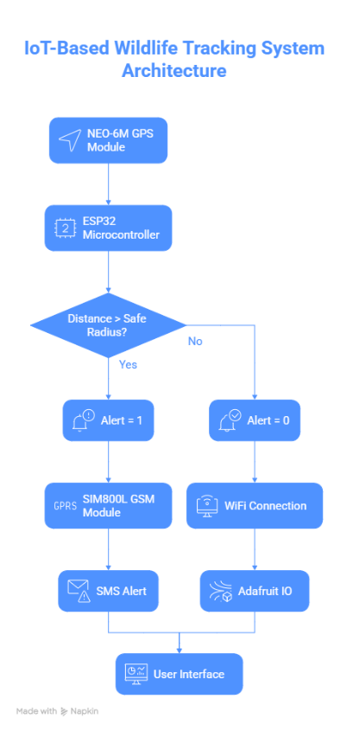

Figure 2.1 Architectural Diagram

ER Modelling / ER Schema Diagram

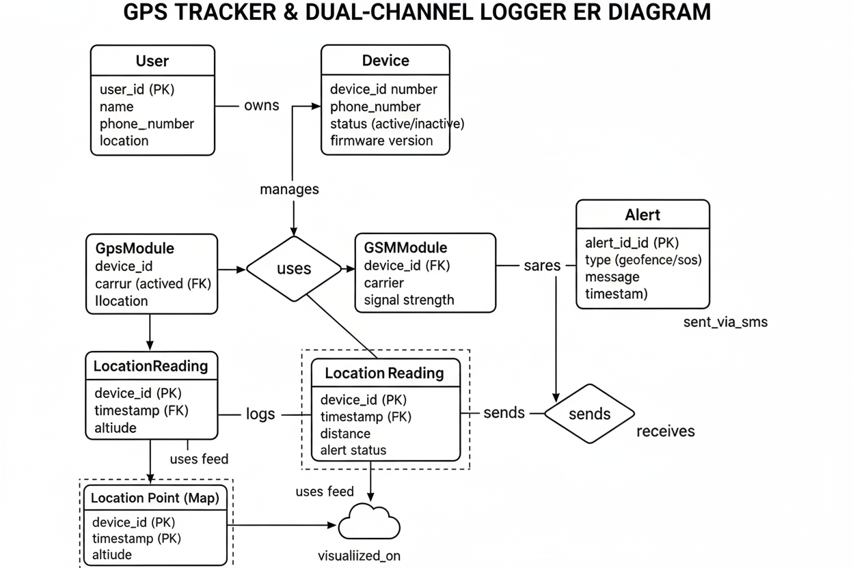
Figure 2.2 ER Schema Diagram

A User manages a Device (tracker) that logs data and triggers alerts through two independent channels. The Device uses a GPSModule to obtain real-time coordinates, and the ESP32 sends continuous Location Readings (latitude, longitude, distance, alert status) to Adafruit IO using WiFi. A separate SIM800L GSMModule is dedicated only for emergency Alerts, sending an SMS to the User’s phone_number whenever the animal crosses the user-defined safe radius. The system performs continuous WiFi-based location tracking, with GSM reserved exclusively for critical geofence notifications.

Chapter 3: System Requirements

Functional Requirements
The system must meet the following functional requirements:
- Acquire the animal’s real-time GPS coordinates (latitude, longitude) using the NEO-6M GPS module.
- Use the ESP32’s WiFi to upload location, distance, and alert status to Adafruit IO via HTTP.
- Provide live map tracking and data visualization on the Adafruit IO dashboard.
- Compute distance from the Home Position and trigger an Alert State when the animal moves beyond the user-defined safe radius.
- Activate the SIM800L GSM module only during geofence violations to send a single SMS alert to the handler’s phone.
- Automatically reconnect to WiFi when signal is lost.
- Perform periodic cloud updates at fixed intervals (every 20 seconds).

Non-Functional Requirements
    - Reliability: The system must operate continuously in outdoor environments, tolerating heat, dust, and humidity. Both communication paths WiFi for data logging and GSM for SMS alerts—must function with high uptime.
    - Accuracy: GPS readings should maintain a precision of ±5 meters in open-sky conditions. Distance computation using the Haversine formula must remain accurate to ensure correct geofence detection.
    - Power Efficiency: The device should minimize power consumption through periodic updates and efficient module usage, ensuring long battery life on 18650 Li-ion cells. The design should also support optional solar-based charging.
    - Scalability: The Adafruit IO cloud backend must support adding multiple tracking devices or new sensors without requiring major architectural changes.
    - Durability: All components must be housed in a rugged, weather-resistant enclosure to ensure reliable functioning during long-term field deployment.
    - Usability: The Adafruit IO dashboard must offer a simple, responsive interface for viewing live location data, alerts, and historical logs on both mobile and desktop devices.

Hardware Requirements
- ESP32 Development Board – Main controller for GPS processing, Wi-Fi connectivity and GSM communication.
- GPS Module (NEO-6M / u-blox) – Provides real-time latitude and longitude of the animal.
- GSM Module (SIM800L) – Sends SMS alert to owner when the animal crosses the safe region.
- × 18650 Li-ion Batteries (3.7 V each) – Primary power supply for portable operation.
- LM2596 DC-DC Buck Converter (x3)
- DC1 – Step down to 5 V for ESP32
- DC2 – Step down to 4.0–4.2 V for GSM module
- DC3 – Battery charging/power management
- On/Off Switch – For powering the device ON and OFF.
- Charging Jack / Connector – To charge the battery pack.
- Antenna for GPS and GSM – For proper signal reception.
- Connecting Wires & Headers – For signal and power wiring.
- Perfboard / Enclosure (optional) – For mounting and protection of components.

Software Requirements
● Development Environment: The firmware for the ESP32 is written, compiled, and uploaded using the Arduino IDE, configured with the ESP32 board support package.
● Cloud Platform: Adafruit IO is used to store and visualize device data (latitude, longitude, distance, alert status) and to display the live map location feed.
● Arduino Libraries Required:
- WiFi.h – Manages connection between ESP32 and WiFi network.
- HTTPClient.h – Handles HTTP POST uploads to Adafruit IO.
- TinyGPSPlus.h – Parses and interprets GPS data from the NEO-6M module.
- Adafruit_MQTT.h – Supports structured communication with Adafruit IO feeds (optional, not used in HTTP mode).
● GSM Requirement: A GSM SIM card with an active SMS plan is required for the SIM800L module, used only for sending critical SMS geofence alerts.
● Cloud Credentials: An Adafruit IO Account is required to generate:
- AIO Username
- AIO Key
- Feed names for latitude, longitude, distance, alert, and location map display.

Working Principle/ Block Diagram

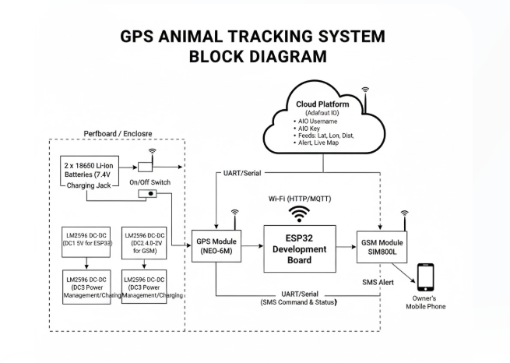

Figure 3.1 Block diagram

The ESP32 microcontroller functions as the central controller of the tracking system. It continuously reads GPS coordinates from the NEO-6M module, calculates the distance from the predefined Home Position, and determines whether the animal is inside or outside the safe radius. For continuous monitoring, the ESP32 uses its built-in WiFi to upload latitude, longitude, distance, and alert status to the Adafruit IO cloud, enabling real-time dashboard visualisation and map tracking. In parallel, the ESP32 manages a second communication channel through the SIM800L GSM module, which is used only for critical events. When a geofence violation occurs, the ESP32 triggers the SIM800L to send an immediate SMS alert to the predefined phone number (e.g., 0123456789). This dual-channel system ensures uninterrupted tracking through WiFi and reliable emergency notifications through GSM, allowing fully remote, automatic, and autonomous operation.

The step-by-step data flow is as follows:

1. GPS Data Acquisition (NEO-6M GPS Module)
The GPS module continuously receives satellite signals and outputs NMEA data.
The ESP32 reads this data and extracts the current latitude and longitude using the TinyGPSPlus library.

2. Processing & Geofence Evaluation (ESP32)
The ESP32 sets the Home Position on the first valid GPS fix. For every new reading, it:
- Calculates the distance from Home Position (in meters).
- Compares it with the user-defined safe radius.
- Sets alert = 0 (inside radius) or alert = 1 (outside radius).
This processed data is then prepared for cloud upload and alert handling.

3. Dual-Channel Communication (WiFi + GSM)
a. WiFi (Primary Channel – Routine Updates)
Using WiFi and HTTP POST, the ESP32 uploads:
- latitude
- longitude
- distance (meters)
- alert state
- location feed
onto Adafruit IO every 20 seconds.
This enables live map tracking and dashboard visualization.
b. GSM (Secondary Channel – Critical Alerts)
If alert = 1, the SIM800L module is triggered to send an immediate SMS to the handler’s phone number
(“0123456789”) containing the live coordinates.
SMS is sent only once per event to avoid spam.

4. Cloud Dashboard & Notification Layer
- The Adafruit IO Dashboard displays real-time location, distance, and alert status with color indicators and a live map.
- The SMS alert ensures the handler receives an instant emergency notification even when WiFi or cloud access is unavailable.

Circuit Diagrams and Screenshots

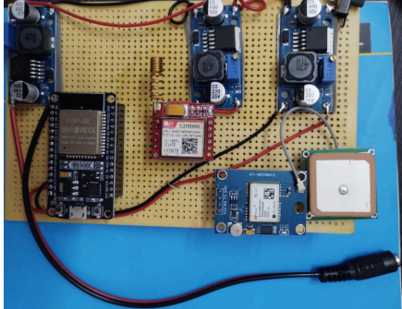
Figure 3.2 Image of project after constructing a working model using the components
Using the above image as source the below image is generated

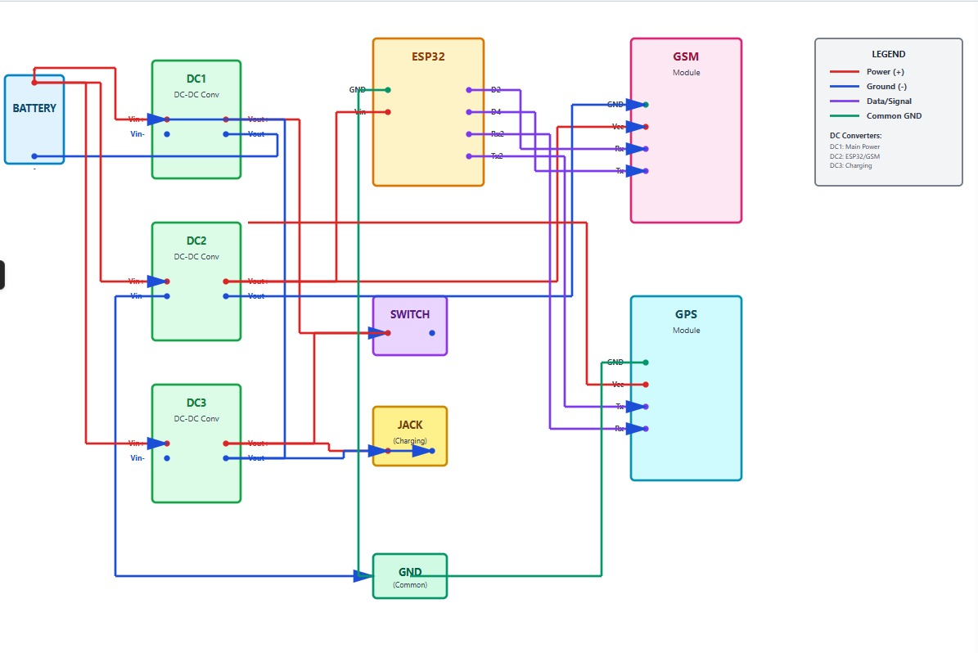
Figure 3.4 Circuit diagram of the working model

Methodology

- Wi-Fi and Adafruit IO Initialization::
cpp
WiFi.begin(ssid, password);
The ESP32 first connects to the specified Wi-Fi network using the SSID and password.
Once connected, the device prepares HTTP-based communication by initializing the Adafruit IO server parameters.
This enables the ESP32 to upload latitude, longitude, distance, and alert status to Adafruit IO using HTTP POST requests.

- GPS Module Setup (NEO-6M Initialization):
Cpp
Serial1.begin(9600, SERIAL_8N1, GPS_RX, GPS_TX);
The GPS module is connected to ESP32 UART1. It continuously sends NMEA sentences that contain real-time coordinates.
The TinyGPSPlus library decodes the data and extracts valid latitude and longitude.
3. Home Position Fixing and Distance Calculation:
cpp
float distanceKm = getDistance(lat, lon, homeLat, homeLon);
float distanceM = distanceKm * 1000.0;
When the GPS provides the first valid fix, the system locks the Home Position, which becomes the center of the geofence zone.
The distance between the animal’s current location and the Home Position is computed using the Haversine formula:
This distance is used to determine if the animal is within or outside the safe radius (user-configurable).

4. Geofence Alert Logic (ESP32 Processing):
cpp
alert = (distanceM > safeRadiusM) ? 1 : 0;
The safe radius is checked continuously. If the distance is greater than the safeRadiusM value, an alert (1) is triggered.
This logic helps decide whether a normal update or a critical SMS alert is required.

5.SMS Alert Transmission (SIM800L GSM Module):
cpp
if (alert == 1 && !smsSent) {
sendSMSAlert(lat, lon);
smsSent = true;
} else if (alert == 0) {
smsSent = false;
}
If the animal crosses the safe radius:
- The alert becomes 1
- An SMS is sent only once per violation (to avoid spamming)
- When the animal returns inside, the SMS flag resets
The SIM800L remains off during normal operation, helping save battery

- Data Upload to Adafruit IO (WiFi):
cpp
sendToAdafruit("latitude", lat);
sendToAdafruit("longitude", lon);
sendToAdafruit("distance", distanceM);
sendToAdafruit("alert", alert);
sendLocationToAdafruit(lat, lon);
.

The ESP32 sends:
Latitude
Longitude
Distance
Alert status
Location feeds (for map display)
using HTTP POST requests.
This enables the Adafruit dashboard to update in real-time.
- Serial Monitor Debug Output:
cpp
Serial.print("Alert: ");
Serial.println(alert);
For local diagnostics, the ESP32 prints key system parameters:
This helps validate computations during development.

- Periodic Update Interval:
cpp
delay(20000);
A delay of 20 seconds is maintained between updates to optimize:
- Power consumption
- Network load
- GPS stability
This ensures regular yet efficient tracking and alerting.

Chapter 4: Implementation and Testing

Modules
The proposed wildlife tracking system is structured into multiple modules, each responsible for a specific functional component. The GPS module captures the animal’s real-time location using NMEA sentences, which are decoded through the TinyGPS++ library to extract latitude and longitude. The ESP32 processing module acts as the central controller, performing operations such as geofence calculation, distance measurement, data filtering, alert decision-making, and sending the processed data to the cloud. The GSM module handles SIM-based communication and is used exclusively for sending SMS alerts whenever the animal crosses the predefined safe radius. Finally, the Adafruit IoT module uploads location and distance data over Wi-Fi, enabling real-time monitoring through map and indicator widgets on an online dashboard.
To support these modules, a reliable power management unit is implemented using two 18650 batteries and multiple DC-DC buck converters to ensure stable voltage levels for the ESP32, GPS, and GSM modules. The entire system was rigorously tested outdoors to evaluate GPS accuracy, geofence responsiveness, network stability, and alert reliability. Each module was validated individually and then integrated to ensure seamless end-to-end operation, confirming that the system can accurately track animal movement, visualize its position, and trigger alerts when necessary.

4.2 Testing
• Unit Testing
Each module was tested independently to verify correct functioning. The NEO-6M GPS was checked for coordinate accuracy and satellite lock stability. ESP32 WiFi connectivity was validated through repeated uploads to Adafruit IO. The SIM800L was tested separately with AT commands to confirm proper SMS transmission.
• Integration Testing
All components were connected together and tested as a unified system. This validated the interaction between the GPS, ESP32, and SIM800L, ensuring that the ESP32 correctly processed GPS data, uploaded it to Adafruit IO, and triggered the GSM module only during geofence violations.
• System Testing
Field tests were performed outdoors. Real-time map updates, location feeds, and alert indicators on Adafruit IO were validated. When the device moved beyond the configured safe radius, an SMS alert was immediately sent to the handler’s mobile number, confirming successful dual-channel communication and complete system reliability.

Chapter 5: Results and Discussions
The developed system successfully functions as a real-time IoT-based wildlife tracking solution with reliable dual-channel communication. The NEO-6M GPS module consistently acquired accurate location data, while the ESP32 processed coordinates, calculated geofence distances, and determined alert status in real-time. The primary communication path, operating through WiFi and HTTP, performed routine data uploads to Adafruit IO, where the device’s movement was displayed through live latitude–longitude feeds and a dynamic map widget. The secondary GSM alert path, controlled by the SIM800L module, was triggered only during geofence violations, ensuring immediate SMS delivery without redundancy.

During practical outdoor testing, the GPS module exhibited an accuracy of approximately ±5 meters under open-sky conditions, meeting the system’s requirements for precise geolocation. Real-time updates were recorded every 20 seconds on the Adafruit IO dashboard, and distance calculations were validated against expected displacement measurements. The geofence mechanism successfully detected when the device moved beyond the 10-meter safety radius. In such cases, the system sent a prompt SMS alert to the registered mobile number, while the dashboard’s alert indicator switched to reflect the breach. When the device returned within range, the alert state correctly reset.

Overall, the system demonstrates reliable performance, low latency in data transmission, and robust alerting through its dual-communication architecture. The results confirm that the solution is cost-effective, energy-efficient, and well-suited for wildlife tracking and safety monitoring. The integration of cloud visualization with direct SMS alerts ensures both continuous monitoring and rapid response capability, making it valuable for conservation authorities and researchers.

Adafruit IO Dashboard Outputs

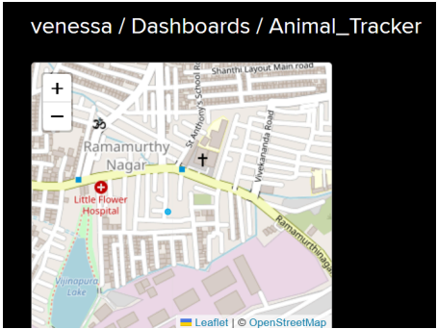
Figure 5.1 Map

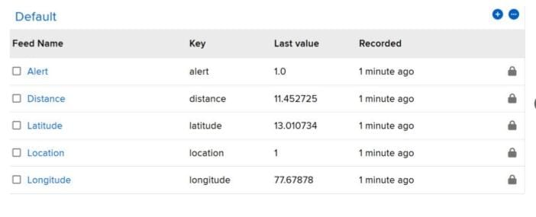
Figure 5.2 Feeds

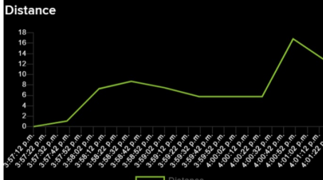
Figure 5.3 Distance Graph


Figure 5.4 Status indicator (when animal is out of range)

Figure 5.5 Status indicator (when animal within the range

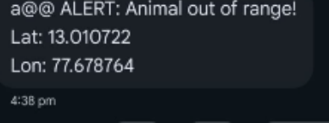
Figure 5.6 SMS Received

The system successfully tracked the device’s live location on the Adafruit IO Dashboard throughout testing. The geofencing mechanism performed accurately, calculating the device’s distance from the base (e.g., detecting out-of-range values in the 111–116 meter range) and immediately issuing an SMS alert through the SIM800L GSM module. This confirmed the reliability of both continuous cloud-based monitoring and the high-priority emergency alert channel. The dashboard also demonstrated flexibility by supporting interactive control feeds such as “Buzzer 1”, showcasing the system’s capability for remote user interaction.

Chapter 6: Conclusion and Future Work

Conclusion

The IoT-based Wildlife Tracking System developed in this project successfully demonstrates a reliable dual-channel architecture for real-time animal monitoring. By integrating the ESP32, NEO-6M GPS module, and SIM800L GSM module, the system efficiently collects accurate geolocation data, processes geofence distance, and transmits information using two independent communication paths. Routine tracking is handled through WiFi, which sends continuous updates latitude, longitude, distance, and alert status to the Adafruit IO cloud platform. This provides a live map, historical logs, and real-time dashboard visibility, making the system suitable for wildlife monitoring applications. The GPS module consistently achieved accuracy within ±5 meters under open-sky conditions, ensuring dependable geofence calculations.
The system’s dedicated GSM channel provides an added layer of safety by sending instant SMS alerts only during geofence violations, ensuring that critical notifications reach the handler even if WiFi coverage is unstable. This redundant communication strategy makes the solution more robust and practical for remote deployment. With its low cost, energy efficiency, wireless accessibility, and accurate tracking performance, the prototype proves to be a scalable and field ready solution to support wildlife conservation, reduce human–animal conflicts, and assist researchers in behavior and movement analysis.

Future Work

To improve and extend the capabilities of the system, the following enhancements are proposed:
- Mobile App Integration: Develop an Android/iOS app to directly receive alerts, view live map tracking, and control device settings without depending solely on the Adafruit Dashboard.
- Machine Learning for Movement Prediction: Use historical GPS data stored on the cloud to predict animal movement patterns, detect anomalies, and anticipate possible human–wildlife conflict events.
- Addition of LoRa / Satellite Communication: Extend network reach to remote forests with limited GSM and WiFi availability by integrating long-range LoRa modules or low-orbit satellite connectivity.
- Optimized Solar Charging: Implement an improved solar-powered energy management system to enable long-term, maintenance-free field operation.
- Multi-Animal Tracking System: Design a centralized monitoring dashboard capable of tracking multiple collars simultaneously, enabling group movement analysis for herds or packs.

References

- Foley, C., et al. (2020). Open-source, low-cost modular GPS collars for monitoring and tracking wildlife. Methods in Ecology and Evolution.

- Maroto-Molina, F., et al. (2019). A Low-Cost IoT-Based System to Monitor the Location of a Whole Herd. Sensors (Basel, Switzerland).

- Babu, V., et al. (2024). Perovskite Solar Module Enabled IoT Asset Tracking for Wildlife Conservation. IEEE Journal of Photovoltaics.

- Aditya, L. M. D., et al. (2025). EfficientDet-Based IoT System for Wildlife Monitoring Using LoRa and Raspberry Pi. IEEE International Conference Proceedings.

- Jiang, Z. (2020). Using the New Technologies and the Internet to Track Wild Animals, Bringing New Opportunities for Wildlife Research and Conservation. Chinese
Science Bulletin.

- Dhivya, K., et al. (2022). A GPS-Based Tracking System for Wildlife Safety. IEEE International Conference on Intelligent Systems.

- Ahmed, S., et al. (2024). A Scalable and Energy-Efficient LoRaWAN-Based Geofencing System for Remote Monitoring of Vulnerable Communities. IEEE Access.

- Reddy, K. C., et al. (2023). Real-Time Tracking of Wildlife with IoT Solutions in Movement Ecology. Journal of Advanced Zoology.

- Kadam, A., et al. (2020). Implementation of IoT Application Using Geofencing Technology for Protecting Crops from Wild Animals. Asia-Pacific Journal of Convergent
Research.

- Sinha, A., et al. (2023). Smart GPS Geofencing System. International Journal of Engineering Research and Technology (IJERT)

Appendices
Appendix 1: Source code (Arduino .ino file, Telegram Bot.py file) Appendix 2: Plagiarism details

CODE

#include <WiFi.h>
#include <TinyGPSPlus.h>
#include <HTTPClient.h>

// ---------- Pin Mapping ----------
#define GPS_RX 16 // ESP32 RX2 <- GPS TX
#define GPS_TX 17 // ESP32 TX2 -> GPS RX
#define SIM_RX 4 // ESP32 GPIO4 <- SIM800 TX
#define SIM_TX 2 // ESP32 GPIO2 -> SIM800 RX

// ---------- WiFi ----------
const char* ssid = "moto g32_2739";
const char* password = "tq3wzcevnybzkfi";

// ---------- Adafruit IO ----------
#define AIO_USERNAME "venessa"
#define AIO_KEY "aio_LYxq242J2GJWGFnOdr7sXRWfQB1s"
const char* aio_server = "http://io.adafruit.com";

TinyGPSPlus gps;

// ---------- Geofence (in METERS) ----------
float safeRadiusM = 10.0; // 10 meter radius

// home position
float homeLat = 0.0;
float homeLon = 0.0;
bool homeSet = false;

// alert state (0 = safe, 1 = out of range)
int alert = 0;

// To avoid SMS spam
bool smsSent = false;

// ---------- Helper: distance between two GPS points (km) ----------
float getDistance(float lat1, float lon1, float lat2, float lon2) {
float dlat = radians(lat2 - lat1);
float dlon = radians(lon2 - lon1);
float a = sin(dlat / 2) * sin(dlat / 2) +
cos(radians(lat1)) * cos(radians(lat2)) *
sin(dlon / 2) * sin(dlon / 2);
float c = 2 * atan2(sqrt(a), sqrt(1 - a));
return 6371 * c; // distance in km
}

// ---------- Helper: send SMS via SIM800 ----------
void sendSMSAlert(float lat, float lon) {
Serial.println(">>> SENDING SMS ALERT...");

String message = "a@@ ALERT: Animal out of range!\nLat: " +
String(lat, 6) + "\nLon: " + String(lon, 6);

Serial2.print("AT+CMGF=1\r");
delay(1000);
Serial2.print("AT+CMGS=\"+918904498811\"\r"); // <-- your phone
delay(1000);
Serial2.print(message);
delay(500);
Serial2.write(26); // CTRL+Z
delay(6000);

while (Serial2.available()) {
Serial.write(Serial2.read());
}
Serial.println("\n📩 SMS alert send attempt done.");
}

// ---------- Helper: send numeric value to Adafruit IO feed ----------
void sendToAdafruit(const String& feed, float value) {
if (WiFi.status() != WL_CONNECTED) {
Serial.println("WiFi not connected, skipping Adafruit IO numeric");
return;
}

HTTPClient http;
String url = String(aio_server) + "/api/v2/" + AIO_USERNAME +
"/feeds/" + feed + "/data";

String payload = String("{\"value\":") + String(value, 6) + "}";

http.begin(url);
http.addHeader("Content-Type", "application/json");
http.addHeader("X-AIO-Key", AIO_KEY);

int httpCode = http.POST(payload);

Serial.print("Adafruit IO [");
Serial.print(feed);
Serial.print("] HTTP status: ");
Serial.println(httpCode);

http.end();
}

// ---------- Helper: send location point to 'location' feed ----------
void sendLocationToAdafruit(float lat, float lon) {
if (WiFi.status() != WL_CONNECTED) {
Serial.println("WiFi not connected, skipping Adafruit location");
return;
}

HTTPClient http;
String url = String(aio_server) + "/api/v2/" + AIO_USERNAME +
"/feeds/location/data";

String payload = String("{\"value\":1,") +
"\"lat\":" + String(lat, 6) + "," +
"\"lon\":" + String(lon, 6) + "}";

http.begin(url);
http.addHeader("Content-Type", "application/json");
http.addHeader("X-AIO-Key", AIO_KEY);

int httpCode = http.POST(payload);
Serial.print("Adafruit IO [location] HTTP status: ");
Serial.println(httpCode);

http.end();
}
// ---------- Setup ----------
void setup() {
Serial.begin(115200);
// GPS on Serial1 (UART1)
Serial1.begin(9600, SERIAL_8N1, GPS_RX, GPS_TX);
// GSM on Serial2 (UART2)
Serial2.begin(9600, SERIAL_8N1, SIM_RX, SIM_TX);

Serial.println("Connecting to WiFi...");
WiFi.begin(ssid, password);
while (WiFi.status() != WL_CONNECTED) {
delay(500);
Serial.print(".");
}
Serial.println("\n✅ WiFi connected!");
Serial.print("IP Address: ");
Serial.println(WiFi.localIP());

Serial.println("System ready (Adafruit only, radius in meters)...");
}
// ---------- Main Loop ----------
void loop() {
// Feed GPS parser
while (Serial1.available() > 0) {
gps.encode(Serial1.read());
}

if (gps.location.isValid()) {
float lat = gps.location.lat();
float lon = gps.location.lng();

// Set home position once (initial safe position)
if (!homeSet) {
homeLat = lat;
homeLon = lon;
homeSet = true;
Serial.println("Home position set.");
}

if (!homeSet) {
Serial.println("Waiting to set home position...");
delay(1000);
return;
}

// Distance in km & meters
float distanceKm = getDistance(lat, lon, homeLat, homeLon);
float distanceM = distanceKm * 1000.0;

// --------- SIMPLE ALERT LOGIC IN METERS ---------
if (distanceM > safeRadiusM)
alert = 1; // outside radius → red
else
alert = 0; // inside radius → green

Serial.println("----------------------------");
Serial.print("Latitude: "); Serial.println(lat, 6);
Serial.print("Longitude: "); Serial.println(lon, 6);
Serial.print("Distance (m): "); Serial.println(distanceM, 1);
Serial.print("Alert: "); Serial.println(alert);

// --------- SMS: only once per out-of-range event ---------
if (alert == 1 && !smsSent) {
sendSMSAlert(lat, lon);
smsSent = true;
} else if (alert == 0) {
smsSent = false;
}

// --------- Adafruit IO numeric feeds ---------
sendToAdafruit("latitude", lat);
sendToAdafruit("longitude", lon);
sendToAdafruit("distance", distanceM);
sendToAdafruit("alert", alert);

// --------- Adafruit IO LOCATION feed for map ---------
sendLocationToAdafruit(lat, lon);

delay(20000);
} else {
Serial.println("⏳ Waiting for GPS fix (move outdoors)...");
delay(3000);
}
}

PLAGARISM CHECK

